Contact: Michelle Quisenberry Director of Marketing & PR
P: 330.263.8143
E:mquisenberry@wchosp.org
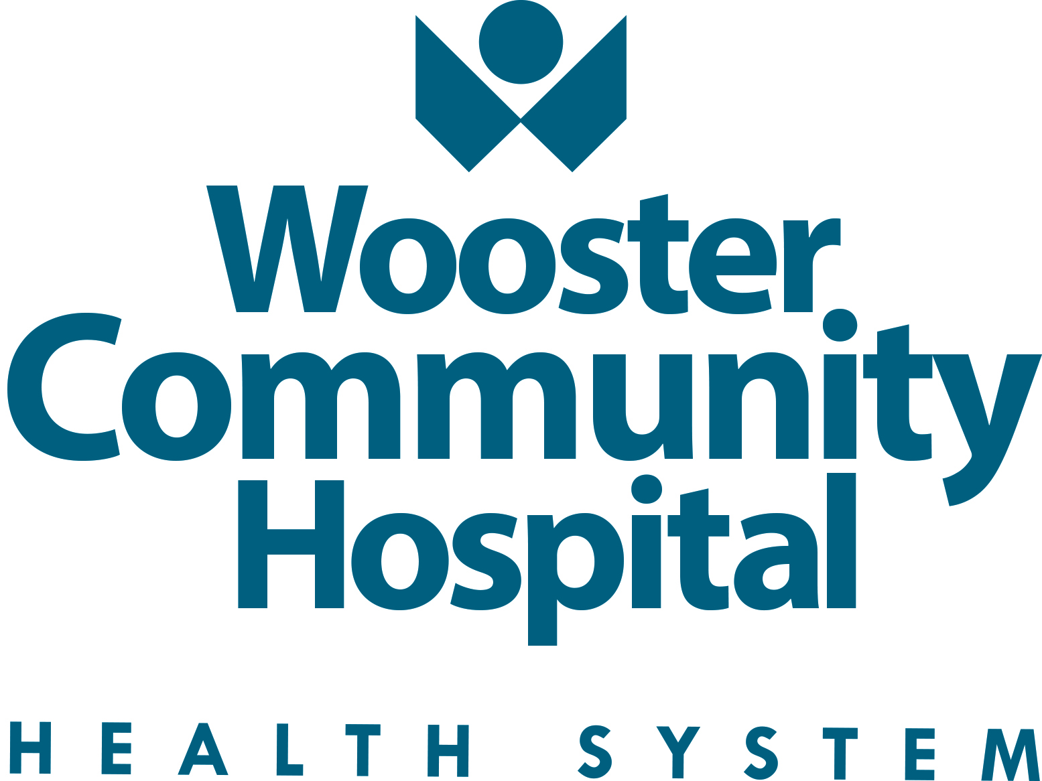

For Immediate Release

Wooster Community Hospital Cancer Program AGAIN Receives Accreditation by the Commission on Cancer
of the American College of Surgeons

WOOSTER (JULY 1, 2021) The Commission on Cancer (CoC), a quality program of the American College of Surgeons (ACS) has granted Three-Year Accreditation to the cancer program at Wooster Community Hospital (WCH) Health System. To earn voluntary CoC accreditation, a cancer program must meet 34 CoC quality care standards, be evaluated every three years through a survey process, and maintain levels of excellence in the delivery of comprehensive patient-centered care.

Because it is a CoC-accredited cancer center, Wooster Community Hospital takes a multidisciplinary approach to treating cancer as a complex group of diseases that requires consultation among surgeons, medical and radiation oncologists, diagnostic radiologists, pathologists, and other cancer specialists. This multidisciplinary partnership results in improved patient care.

“Accreditation is outside validation of our program and its adherence to established quality stands. We applaud our cancer team for achieving this accreditation,” said Bill Sheron, WCH President/CEO.

The CoC Accreditation Program provides the framework for Wooster Community Hospital to improve its quality of patient care through various cancer-related programs that focus on the full spectrum of cancer care including prevention, early diagnosis, cancer staging, optimal treatment, rehabilitation, life-long follow-up for recurrent disease, and end-of-life care. When patients receive care at a CoC facility, they also have access to information on clinical trials and new treatments, genetic counseling, and patient centered services including psycho-social support, a patient navigation process, and a survivorship care plan that documents the care each patient receives and seeks to improve cancer survivors’ quality of life.
Like all CoC-accredited facilities, Wooster Community Hospital maintains a cancer registry and contributes data to the National Cancer Data Base (NCDB), a joint program of the CoC and American Cancer Society. This nationwide oncology outcomes database is the largest clinical disease registry in the world. Data on all types of cancer are tracked and analyzed through the NCDB and used to explore trends in cancer care. CoC-accredited cancer centers, in turn, have access to information derived from this type of data analysis, which is used to create national, regional, and state benchmark reports. These reports help CoC facilities with their quality improvement efforts.
The American Cancer Society estimates that more than 1.9 million new cancer cases will be diagnosed in 2021. There are currently more than 1,500 CoC-accredited cancer programs in the U.S. and Puerto Rico, CoC-accredited facilities diagnose and/or treat more than 70 percent of all newly diagnosed patients with cancer. When cancer patients choose to seek care locally at a CoC-accredited cancer center, they are gaining access to comprehensive, state-of-the-art cancer care close to home. The CoC provides the public with information on the resources, services, and cancer treatment experience for each CoC-accredited cancer program through the CoC Hospital Locator at https://www.facs.org/search/cancer-programs.

About CoC
Established in 1922 by the American College of Surgeons, the CoC is a consortium of professional organizations dedicated to improving patient outcomes and quality of life for cancer patients through standard-setting, prevention, research, education, and the monitoring of comprehensive, quality care. Its membership includes Fellows of the American College of Surgeons. For more information, visit: www.facs.org/cancer

About Wooster Community Hospital
Wooster Community Hospital (WCH) is a 172-bed, full-service and acute-care facility. Located in Wooster, the hub of Wayne County, Ohio. WCH is a 7-time Fortune/IBM Watson Health 100 Top Hospital that offers a complete range of inpatient and outpatient services. WCH has continued to expand facilities and add services to meet the needs of our community. Most recently, was also named by CMS (Centers for Medicare Services) as a 5-Star facility and recognized as part of Newsweek’s annual list of World’s Best Hospitals for 2020/2021. For more information, visit www.woosterhospital.org.

# # #

